LAB # 8

**SCIPY AND MATPLOTLIB**

**OBJECTIVE :** Scientific computing and technical computing with plotting using SciPy and matplotlib library in python

**Task 1:**

**Code:**

import matplotlib.pyplot as Plt

import numpy as np

x = np.arange(10)

Plt.plot(x,x,)

Plt.plot(x, 2 * x)

Plt.plot(x, 3 * x)

Plt.plot(x, 4 * x)

Plt.gca().get_lines()[0].set_color("orange")

Plt.gca().get_lines()[1].set_color("red")

Plt.gca().get_lines()[2].set_color("blue")

Plt.gca().get_lines()[3].set_color("yellow")

Plt.gca().legend(('y = x', 'y = 2x', 'y=3x’,’y=4x'))

Plt.show()

**Output:**

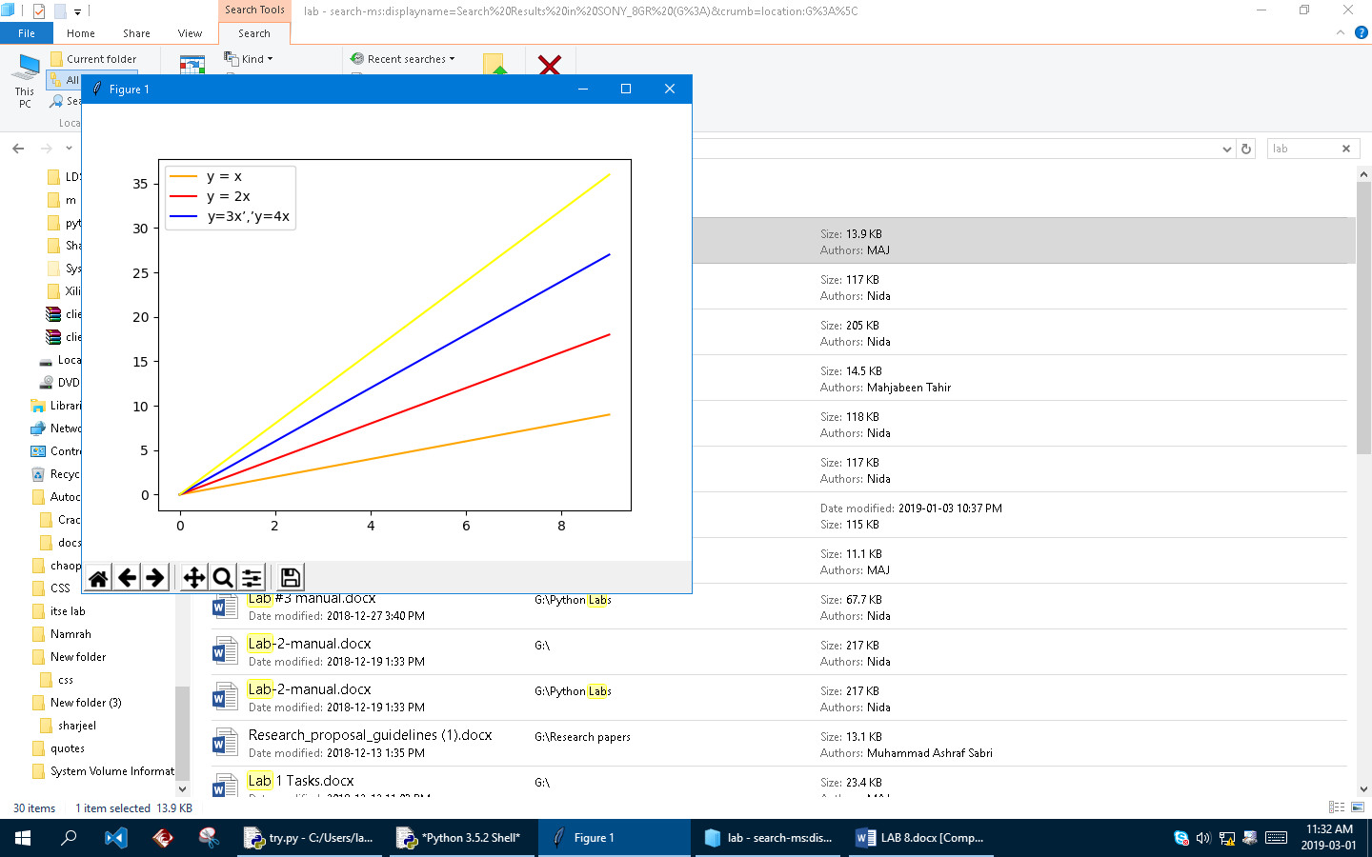

**TASK 2**

**CODE:**

import matplotlib.pyplot as plt

import numpy as np

x = np.linspace(-10, 10, 1000)

y = x**2 + 2*x + 2

fig, ax = plt.subplots()

ax.plot(x,y)

plt.title('Parabola')

plt.show()

OUTPUT

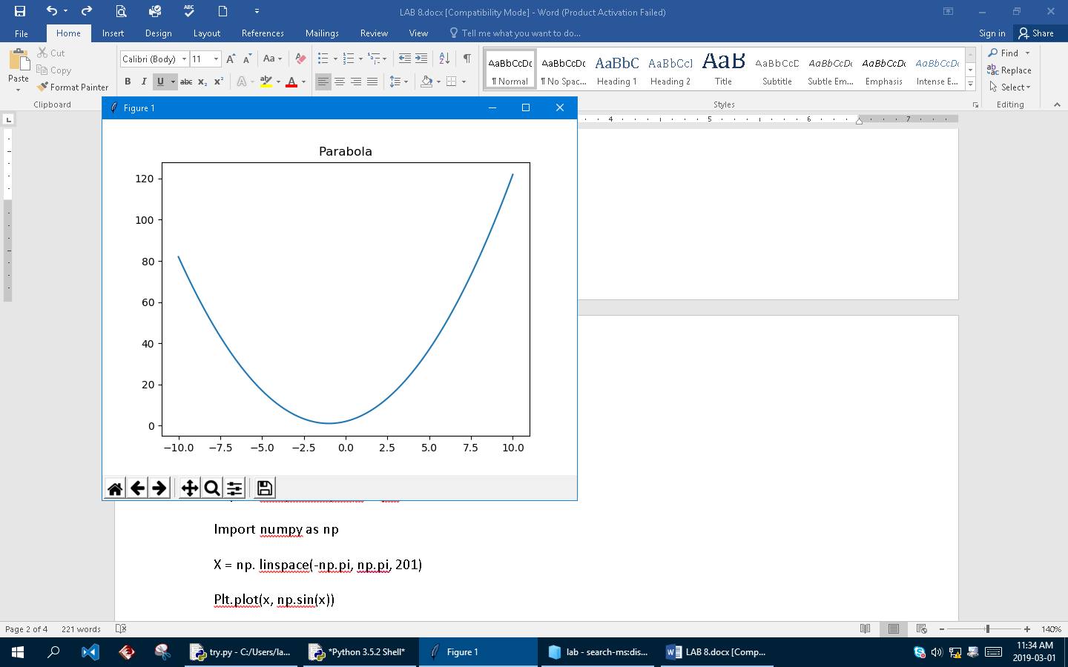

**TASK 3**

**CODE**

import matplotlib.pylab as Plt

import numpy as np

x = np. linspace(-np.pi, np.pi, 201)

Plt.plot(x, np.sin(x))

Plt.plot(x, np.cos(x))

Plt.axis('equal')

Plt.gca().legend(('sine function','cosine function'))

Plt.show()

**OUTPUT**

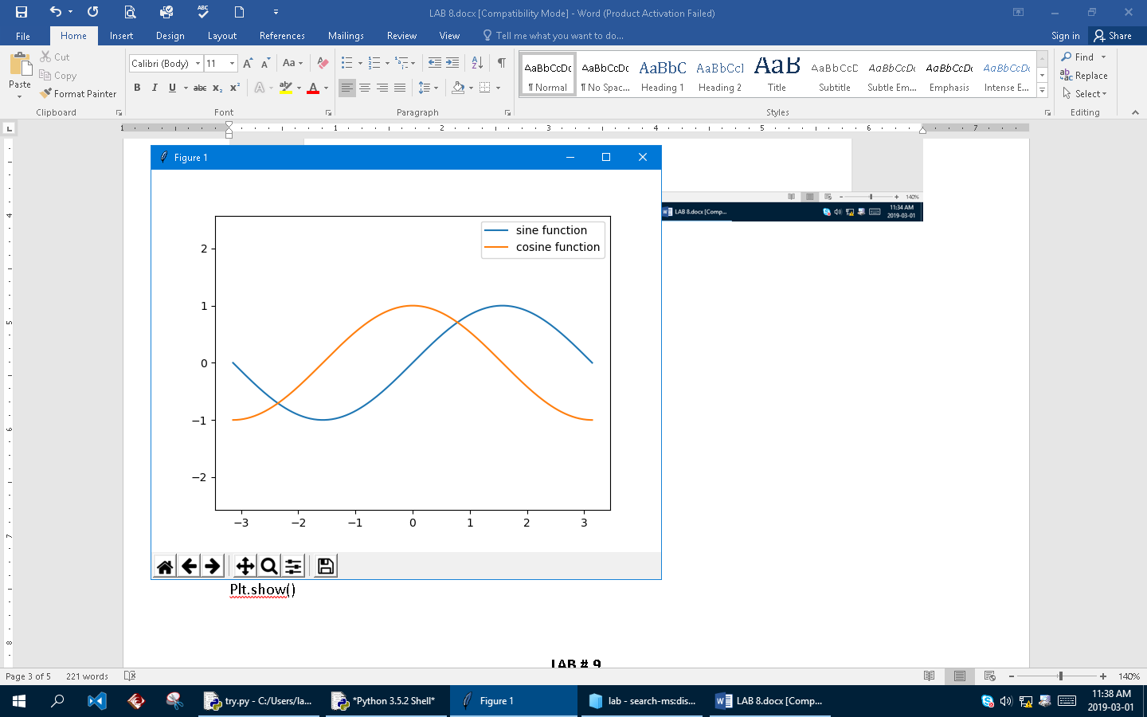

**LAB # 9**

**OBJECTIVE**

Familiarization with fuzzy logic system using Scikit fuzzy

**TASK 1**

1. Implementation of Union and intersection in fuzzy using Built-in function in skfuzzy

**Code**

import numpy as np

import skfuzzy as fuzz

uni_x = np.array([1,2,4,5,6])

uni_y = np.array([1,2,4,5,6])

mfx = np.array([0.3,0.1,0.7,0.9],float)

mfy = np.array([0.6,0.2,1,0.3],float)

print(fuzz.fuzzy_or(uni_x,mfx,uni_y,mfy))

print(fuzz.fuzzy_and(uni_x,mfx,uni_y,mfy))

**OUTPUT**

(array([1, 2, 4, 5, 6]), array([0.6, 0.2, 1. , 0.9]))

(array([1, 2, 4, 5, 6]), array([0.3, 0.1, 0.7, 0.3]))

1. Implementation of cartesian addition of fuzzy membership vector using algrebraic method using cartadd(x,y)

**CODE**

import numpy as np

import skfuzzy as fuzz

uni_x = np.array([1,2,4,5,6])

uni_y = np.array([1,2,4,5,6])

mfx = np.array([0.3,0.1,0.7,0.9],float)

mfy = np.array([0.6,0.2,1,0.3],float)

print(fuzz.cartadd(mfx,mfy))

**Output:**

[[0.9 0.5 1.3 0.6]

[0.7 0.3 1.1 0.4]

[1.3 0.9 1.7 1. ]

[1.5 1.1 1.9 1.2]]

1. Implementation of cartesian product of two fuzzy membership vector using algrebraic method using cartprod(x,y)

**CODE**

import numpy as np

import skfuzzy as fuzz

uni_x = np.array([1,2,4,5,6])

uni_y = np.array([1,2,4,5,6])

mfx = np.array([0.3,0.1,0.7,0.9],float)

mfy = np.array([0.6,0.2,1,0.3],float)

print(fuzz.cartprod(mfx,mfy))

**Output:**

[[0.3 0.2 0.3 0.3]

[0.1 0.1 0.1 0.1]

[0.6 0.2 0.7 0.3]

[0.6 0.2 0.9 0.3]]